**PROJECT-3**

**COLOR TRANSFORMATION**

EE5356 Digital Image Processing

Dr. K. R. Rao

Submitted By:

Ashutosh Desai

UTA ID:1001388602

Email:ashutoshrajesh.desai@mavs.uta.edu

Feb 22th 2018

EE5356 LAB Assignment #3

Color Transformation

The test image, **Girl256color.raw** (the size is 256*256 pixels) , for this assignment is available at the class website.

Problem 1: RGB component decomposition

1) Decompose a given 24bit color image (raw format) into 3 Red, Green,

and Blue components and **show those images** in your report and **explain**

**the procedure** (how to get these.)

2) Reconstruct the color image from these three RGB components, and

**show the reconstructed color image** with your explanation.

NOTE:

1: Please explain **in writing** and not just by attaching a source code.

2: Since the format of an image is raw format, you cannot use any builtin

MATLAB function to do this assignment. You have to open the file by

your self to access to data in the image.

3: You can use ‘image.m’ function to display the reconstructed color image

if you use MATLAB. See the details by typing ‘help image’ in the

MATLAB command window.

Problem 2: Color transformation

***Given*** the conversion of the gamma corrected and normalized tri-stimulus

analog signals R, G, and B to component YUtVt signals is defined as

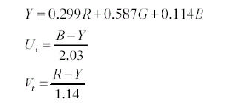

i.e.

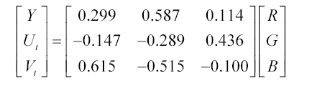

and the inverse transform is:

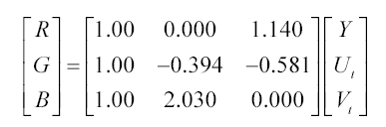

RGB to digital component YdCbCr conversion is given by

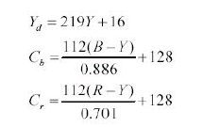

i.e.,

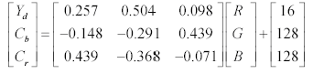

And the inverse transform is:

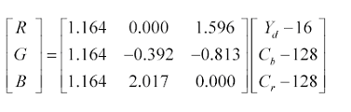

where digital luminance, Yd, has a range of (16-235) with 220 levels

starting at 16, and digital chrominance difference signals, Cb and Cr, have

a range of (16-240) with 225 levels centered at 128, then **apply these**

**transforms to get YUtVt and YdCbCr from RGB components you**

**obtained in problem 1. Show all the 6 components.**

NOTE:

1: **R=G=B=1** corresponds to reference white C of unity luminance.

2: You may use ‘imshow.m’ to do the scaling of those obtained

components which have a range of (0 1.0) .

**Hint:**

The steps to be followed:

- Open colored raw file

- Convert open file into an image of 256*256*3

- RGB component decomposition

     Red components are present at 1,4,7...

     Green  ''                     ''                   2,5,8...

     Blue   "                     "                      3,6,9...

- Break RGB image into R-image, G-image and B-image

- Initialize zero vectors of size 256*256 for display

- Display R, G, B component.

**MATLAB-CODE: -**

clc;

clear all;

close all;

Img = fopen('D:\STUDY\DIP\Test img\girl256color.raw','r');

Img_Ip = fread(Img);

RED = reshape(Img_Ip(1:3:length(Img_Ip)),256,256)';

GREEN = reshape(Img_Ip(2:3:length(Img_Ip)),256,256)';

BLUE = reshape(Img_Ip(3:3:length(Img_Ip)),256,256)';

%Input Image

I(:,:,1) = RED;

I(:,:,2) = GREEN;

I(:,:,3) = BLUE;

figure(1);

image(uint8(I));

title('Reconstructed Image');

figure(2);

subplot(3,3,1);

image(uint8(RED));

title('Red');

subplot(3,3,2);

image(uint8(GREEN));

title('Green');

subplot(3,3,3);

image(uint8(BLUE));

title('Blue');

%Y U V decompositions

Y = RED*0.299 + GREEN*0.587 + BLUE*0.114;

U = RED*-0.147 + GREEN*-0.289 + BLUE*0.436;

V = RED*0.615 + GREEN*-0.515 + BLUE*-0.1;

subplot(3,3,4);

image(uint8(Y));

title('y');

subplot(3,3,5);

image(uint8(U));

title('u');

subplot(3,3,6);

image(uint8(V));

title('v');

%y Cb Cr decompositions

Re_yd =RED*0.257 + GREEN*0.504 + BLUE*0.098 +16;

Re_cb = RED*-0.148 + GREEN*-0.291 + BLUE*0.439+128;

Re_cr = RED*0.439 + GREEN*-0.368 + BLUE*-0.071+128;

subplot(3,3,7);

image(uint8(Re_yd));

title('yd');

subplot(3,3,8);

image(uint8(Re_cb));

title('cb');

subplot(3,3,9);

image(uint8(Re_cr));

title('cr')

**OUTPUT: -**

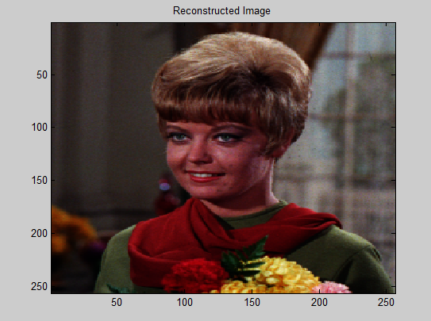

***Figure 1:- Reconstructed Image***

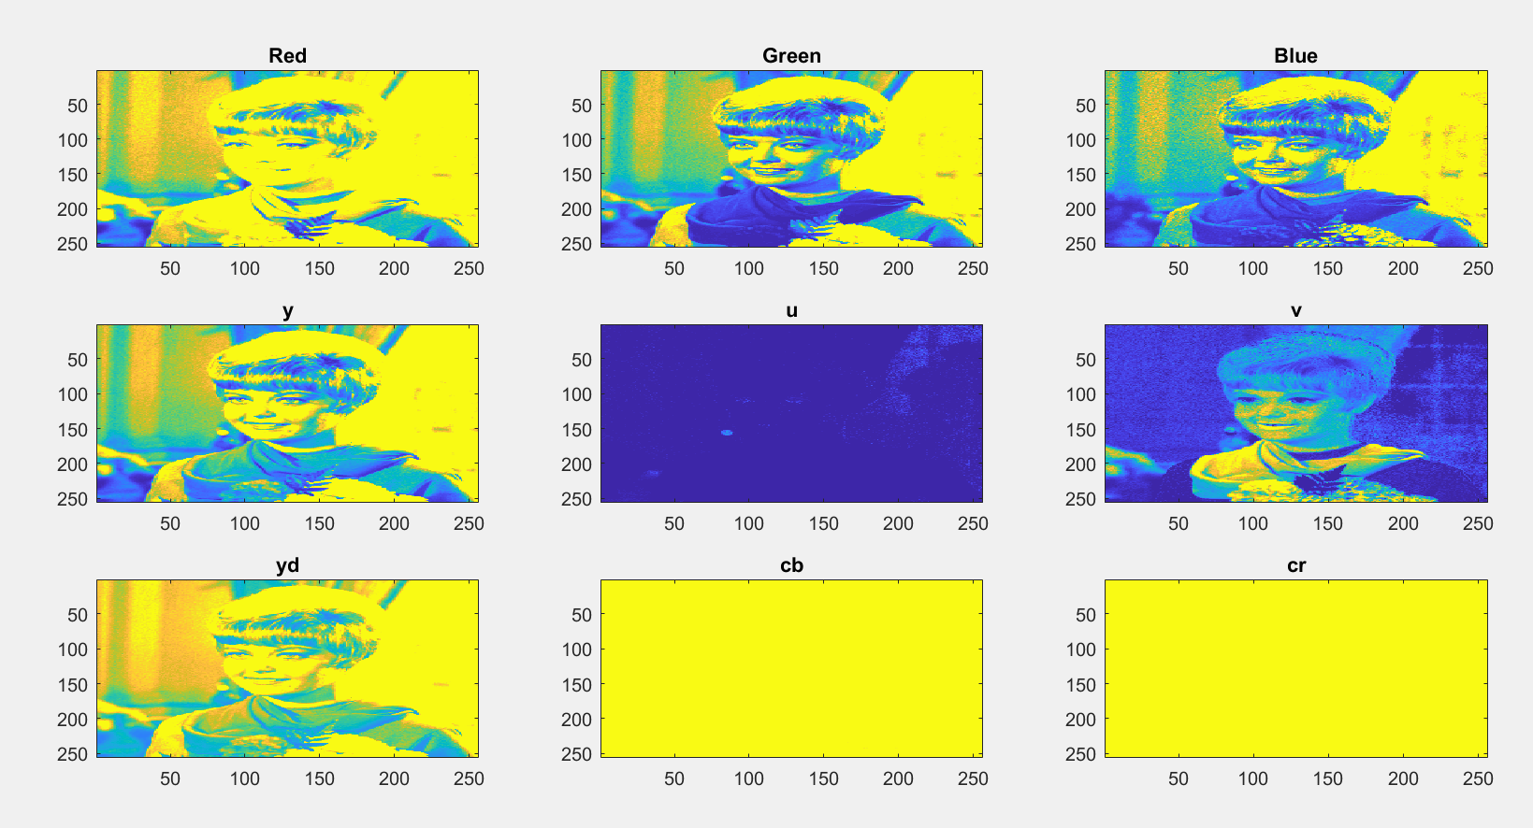

***Figure 2: -Decompositions of the original image*** ***Girl256color.raw***

**PROCEDURE:-**

* Initially we will open the image file using the **fopen** command available in matlab, followed by the command **fread**. This set of commands enters the image into a variable input as a 3 dimensional variable on which further operations are performed.
* Thereafter by using the reshape command we derive the respective red, green and blue components of the image. Thus the reshape command provides the three components of the image in the form of a 256*256 matrix each which is then representated in the form of image using the **subplot** command.
* From the **RGB** components we obtain the corresponding “**Y U V”** and “**Y Cb Cr”** components using the formula mentioned above in this project.
* Thus after obtaining the decompositions this decompositions are then combined to obtain the the reconstructed image.

**Conclusion: -**

Thus it can be conclude that the reconstructed image obtained from the decompositions is very much similar to the original image.